Data Flow Diagram
Date | 01 October 2026
Team ID | SWTID-2026-2351
Project Name | Auto Ticket Classification using Flow Designer
Maximum Marks | 2 Marks

Data Flow Diagram
The diagram shows how data moves between the external entities (Caller, IT Support Staff), the processes in the system and the data stores (Incident Workflow table and Email Log).
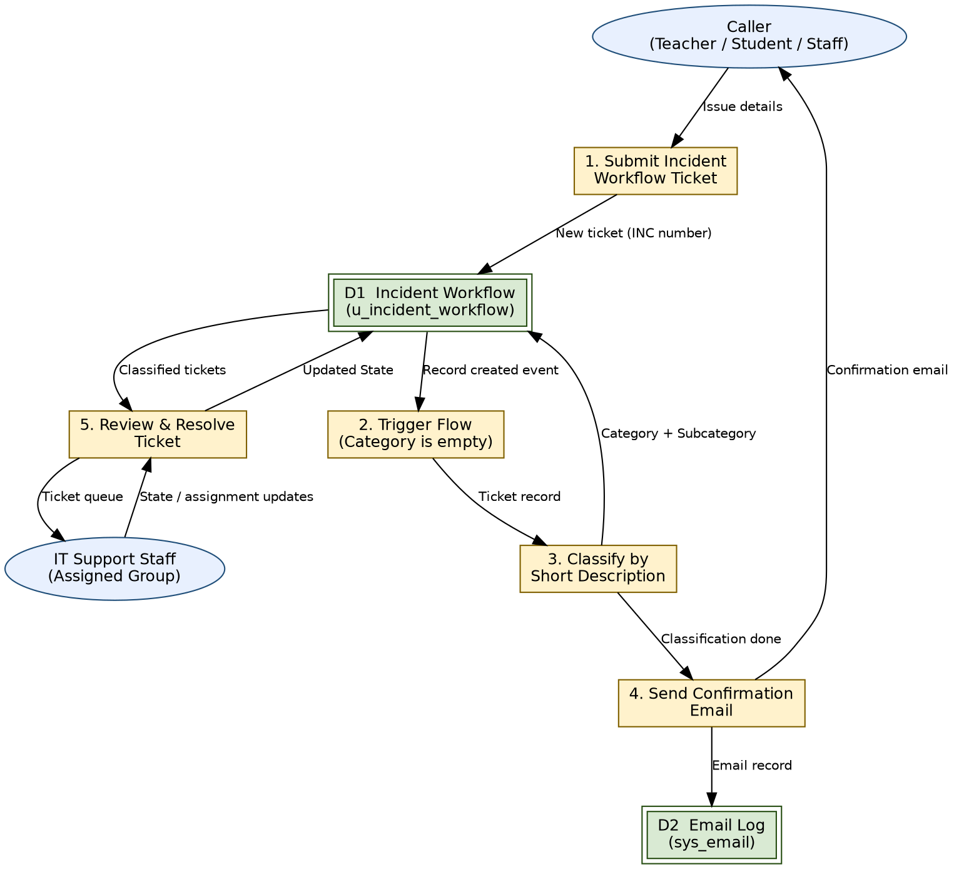
Figure 1: Data Flow Diagram of the Auto Ticket Classification system

Elements
Type | Name | Description
External Entity | Caller | Teacher, student or staff member who submits an IT issue and receives the confirmation email.
External Entity | IT Support Staff | Reviews classified tickets, assigns them and updates State.
Process | 1. Submit Incident Workflow Ticket | Caller fills the form; a number such as INC0001001 is generated and the record is saved.
Process | 2. Trigger Flow | Flow starts when an Incident Workflow record is created where Category is empty.
Process | 3. Classify by Short Description | If / Else If conditions match Wi-Fi, Projector, Forgot password or Slow computer and update Category and Subcategory.
Process | 4. Send Confirmation Email | Sends "Your IT ticket has been successfully submitted and classified."
Process | 5. Review & Resolve Ticket | IT staff work the ticket through New, In progress, On hold, Resolved and Closed.
Data Store | D1 Incident Workflow (u_incident_workflow) | Stores all tickets and their classification.
Data Store | D2 Email Log (sys_email) | Stores the outbound confirmation emails.

